**Overview and General Satisfaction**

The survey, which received 47 responses, indicates an overall positive reception towards NiChart, with respondents finding its concept and usage clear. Users who tested the application reported a smooth experience and were satisfied with the results. There is a high reported likelihood of users recommending the application to their colleagues, with scores frequently at or above 8 out of 10.

**Engagement and Feedback**

The survey highlighted varied interest among users in different components of the project, such as image processing methods and machine learning applications. A significant portion of users, 22 in fact, expressed willingness to provide detailed feedback and are available for further surveys, questions, or even a detailed interview. The feedback received was valuable, expressing appreciation for the tool and highlighting areas for improvement. Specifically, respondents outlined the need for inclusion of additional data types (like PET, ASL), the need for flexibility of usage, as well as some minor fixes.

**Detailed Findings**

* **Clarity of Concept**: All respondents indicated that the definition of NiChart was clear, underlining the effectiveness of the project's communication.
* **Importance of Aspects**: The aspects deemed most important varied, with 'Image processing methods' and 'Machine learning applications' frequently rated as 'Very important' or 'Important'. This reflects the users' interest in the technical capabilities of NiChart.
* **Application Usage and Satisfaction**: Among those who used the application, everyone reported that it worked smoothly and provided satisfactory results. This indicates that the practical application of NiChart meets user expectations.
* **Recommendation Likelihood**: The willingness to recommend the application was high, with scores predominantly at the upper end of the scale (8-10), suggesting strong endorsement among users.
* **Feedback and Suggestions**: While specific feedback varied, it included both constructive suggestions for improvement and positive remarks. Notably, one respondent suggested the inclusion of PET data, indicating specific user needs and potential areas for expansion.

**Conclusion**

The survey conducted on NiChart users provides insightful feedback on the application's clarity, utility, and areas for enhancement. Overall, users showed a high level of satisfaction and engagement, with a strong inclination to recommend NiChart to colleagues. The feedback received not only affirms the value of NiChart but also offers directions for future development, ensuring that the application continues to meet and exceed user expectations.

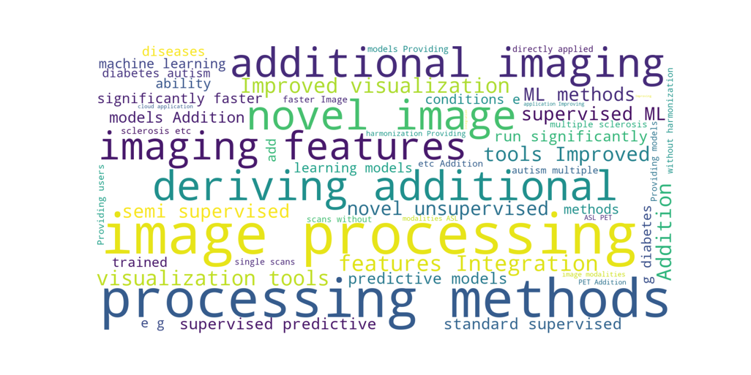

Figure : Future feature demand wordcloud

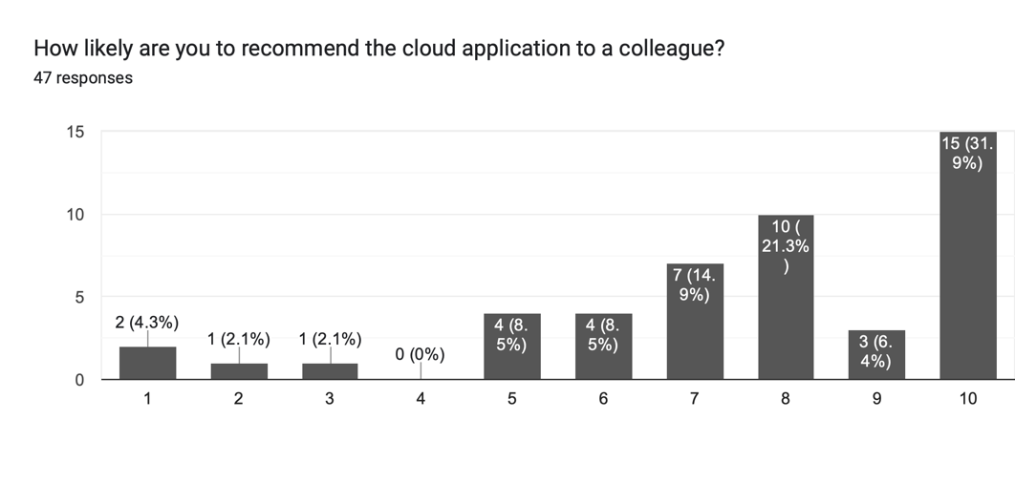

Figure : Likelihood of referal to a colleague

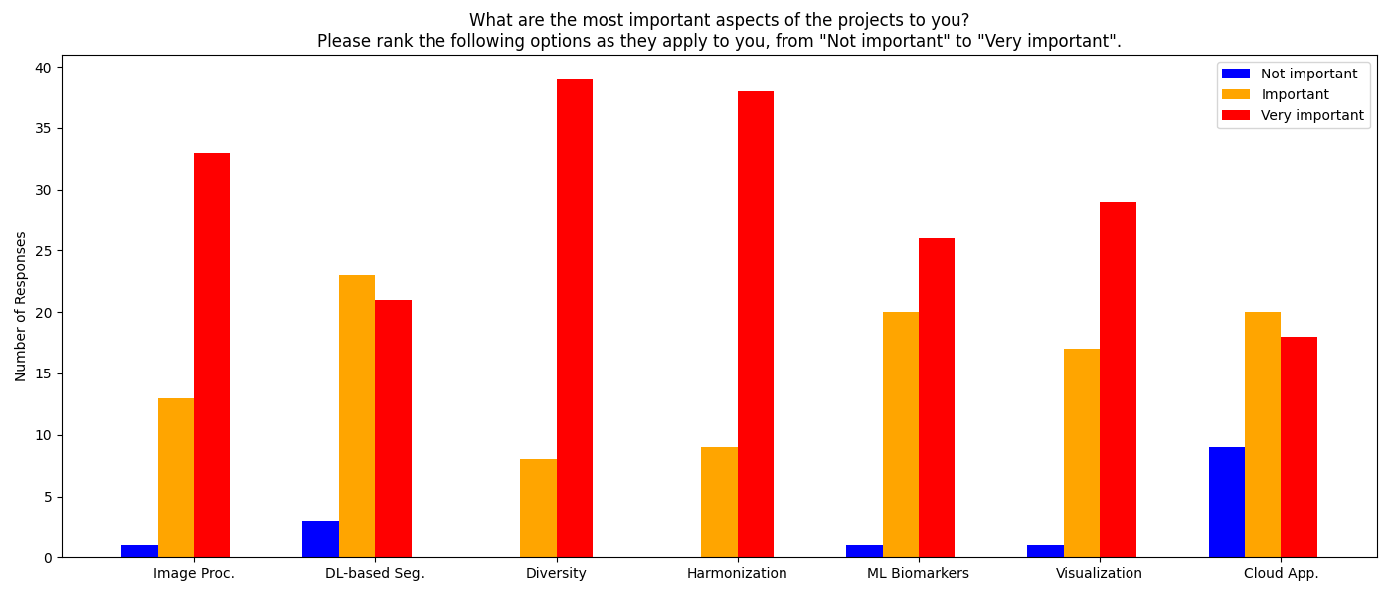

Figure : User Ranking of Project Features from Least to Most Important